* Chapter – 1 – Python Introduction
* 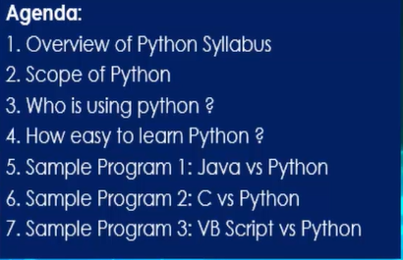
* Graphical user interface, application

  Description automatically generated
* Graphical user interface, website

  Description automatically generated
* Scope of Python

* **Python – Can be used in many fields where as R is purely used by Data Scientist**
* **How to choose Python IDE and Installation Steps**

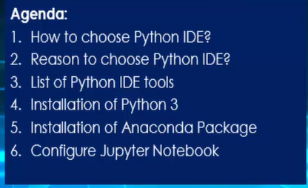

* **IDE** – Integrated Development Environment
* Different Python IDEs

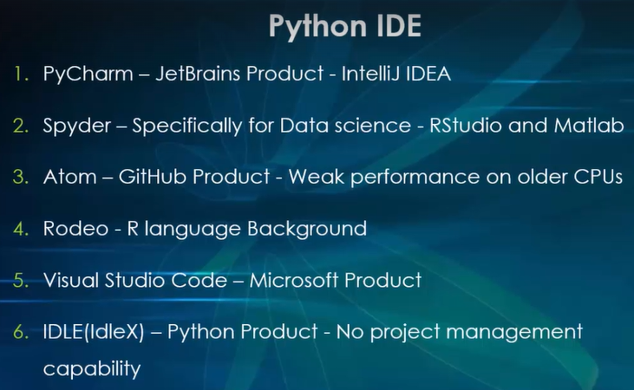

* Installations steps
* Install python software.
* Install Anaconda
* Configure Jupyter Notebook
* Overview of Jupyter Notebook and Python Programming Basics

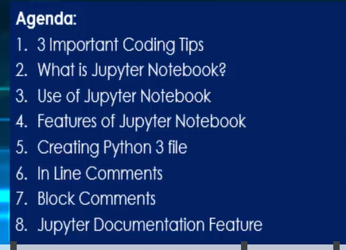

* Important coding tips

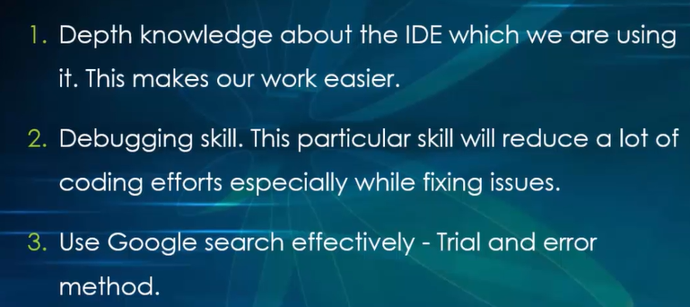

* It is always important to comment in your program; in order to help others to understand what the program does.
* Graphical user interface, text

  Description automatically generated

 -- inline comment

-- block comment

* Explained about Markdown

* **Identifiers and Reserved Keywords**

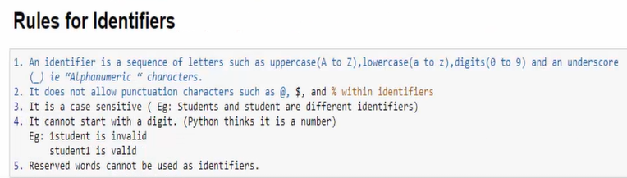

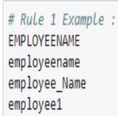

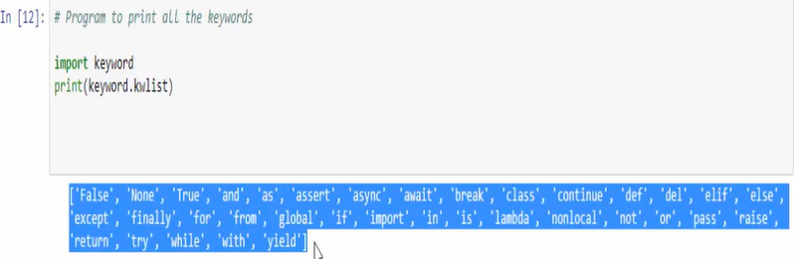

* Variables:

* Data Types

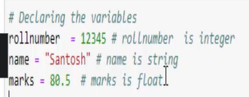

* 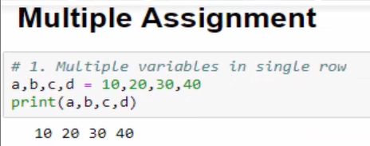

* Graphical user interface, text

  Description automatically generated

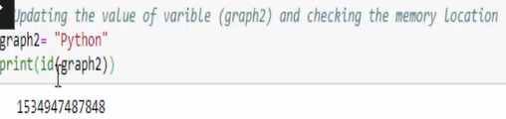

* **Id() -**  this is a build in function which returns the unique address location of a variable